**Name: Adedapo Abiodun Joseph**

**Matric: 2019235020021**

**Course: Database Design (COM312)**

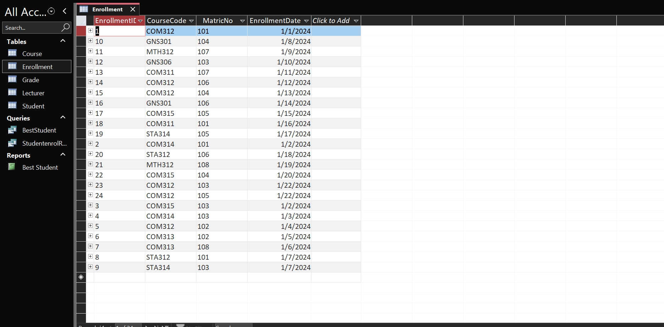**Enrollment Table**

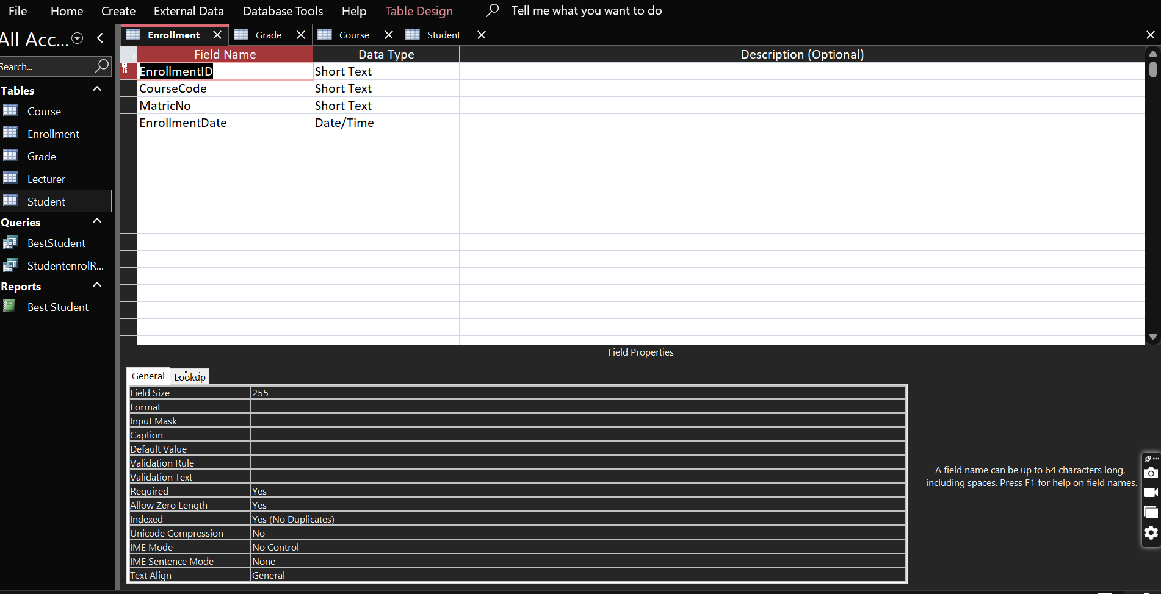Datasheet View

Design View

**Student Table**

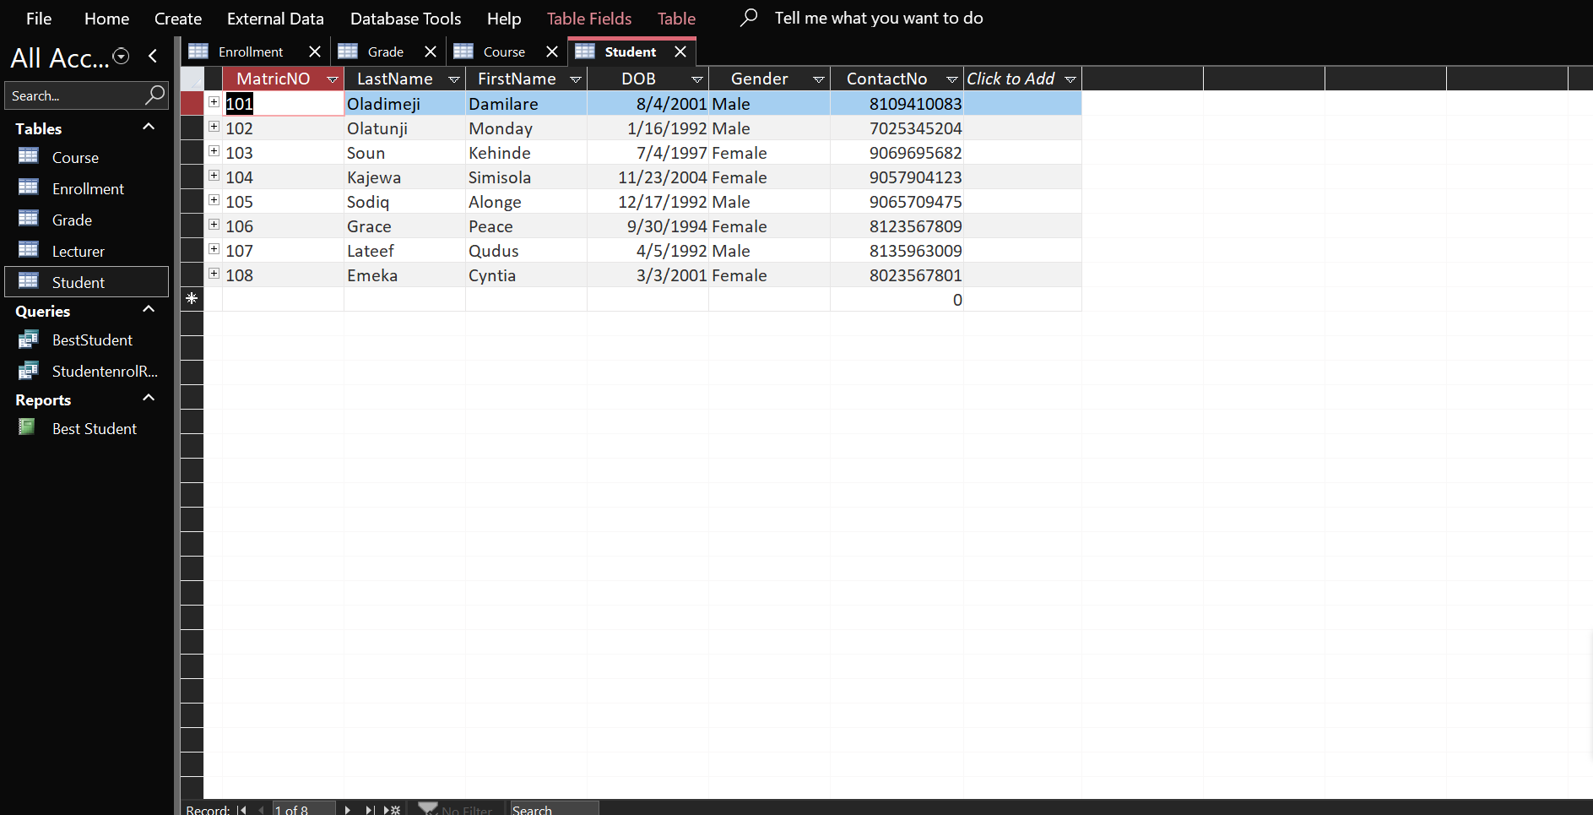

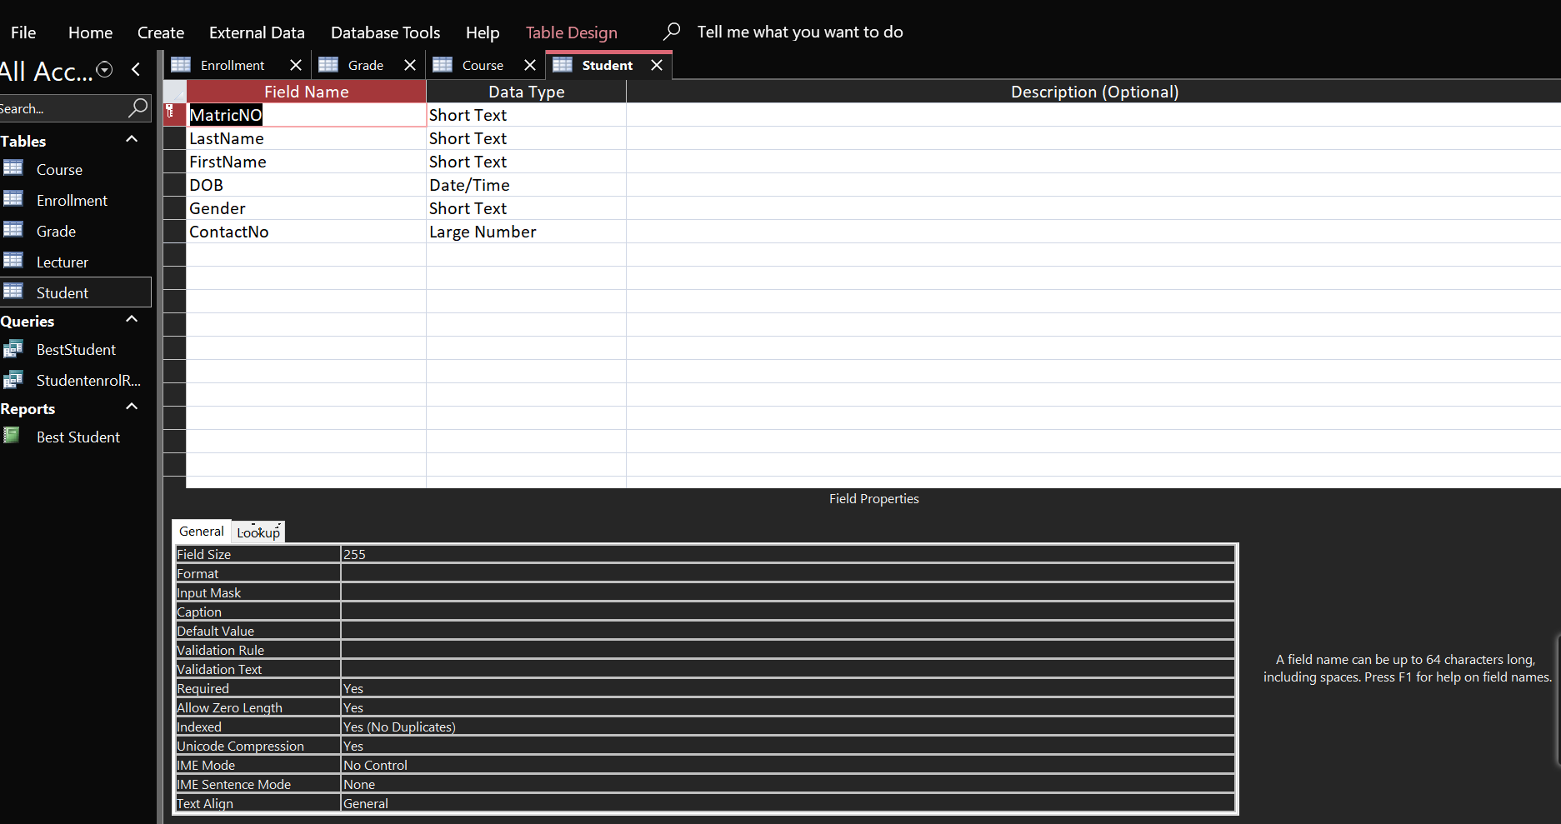Datasheet view

Design View

**Grade Table**

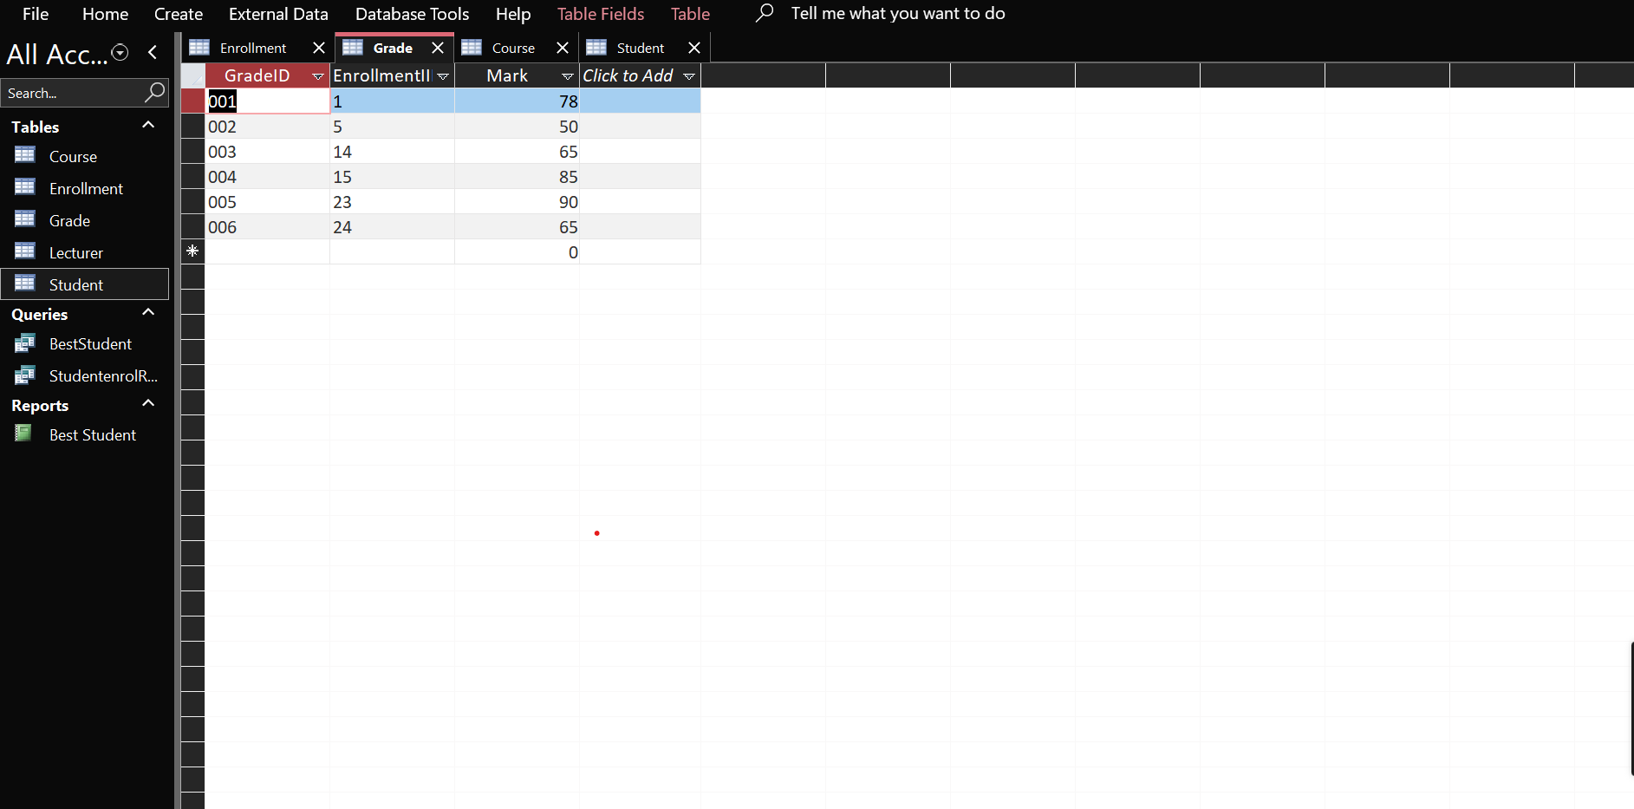

Datasheet View

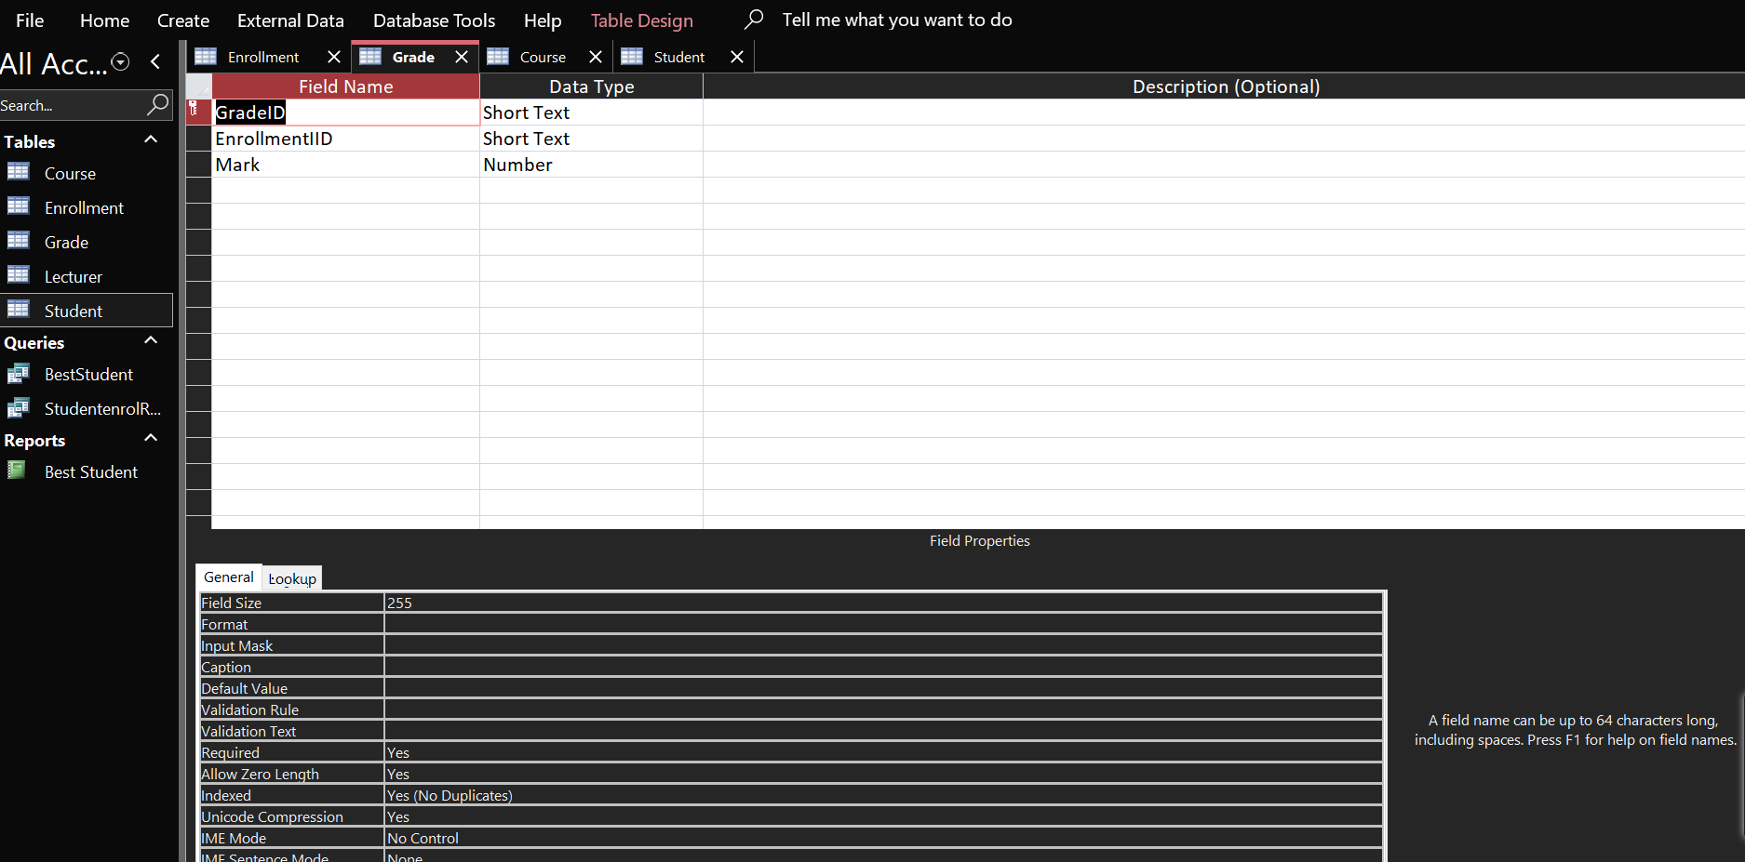

Design View

**Course Table**

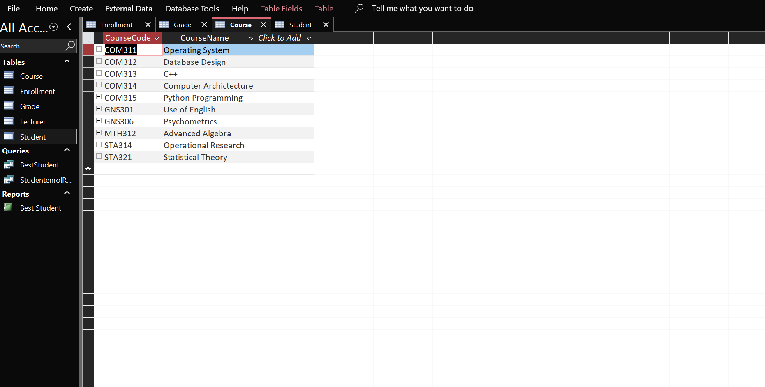

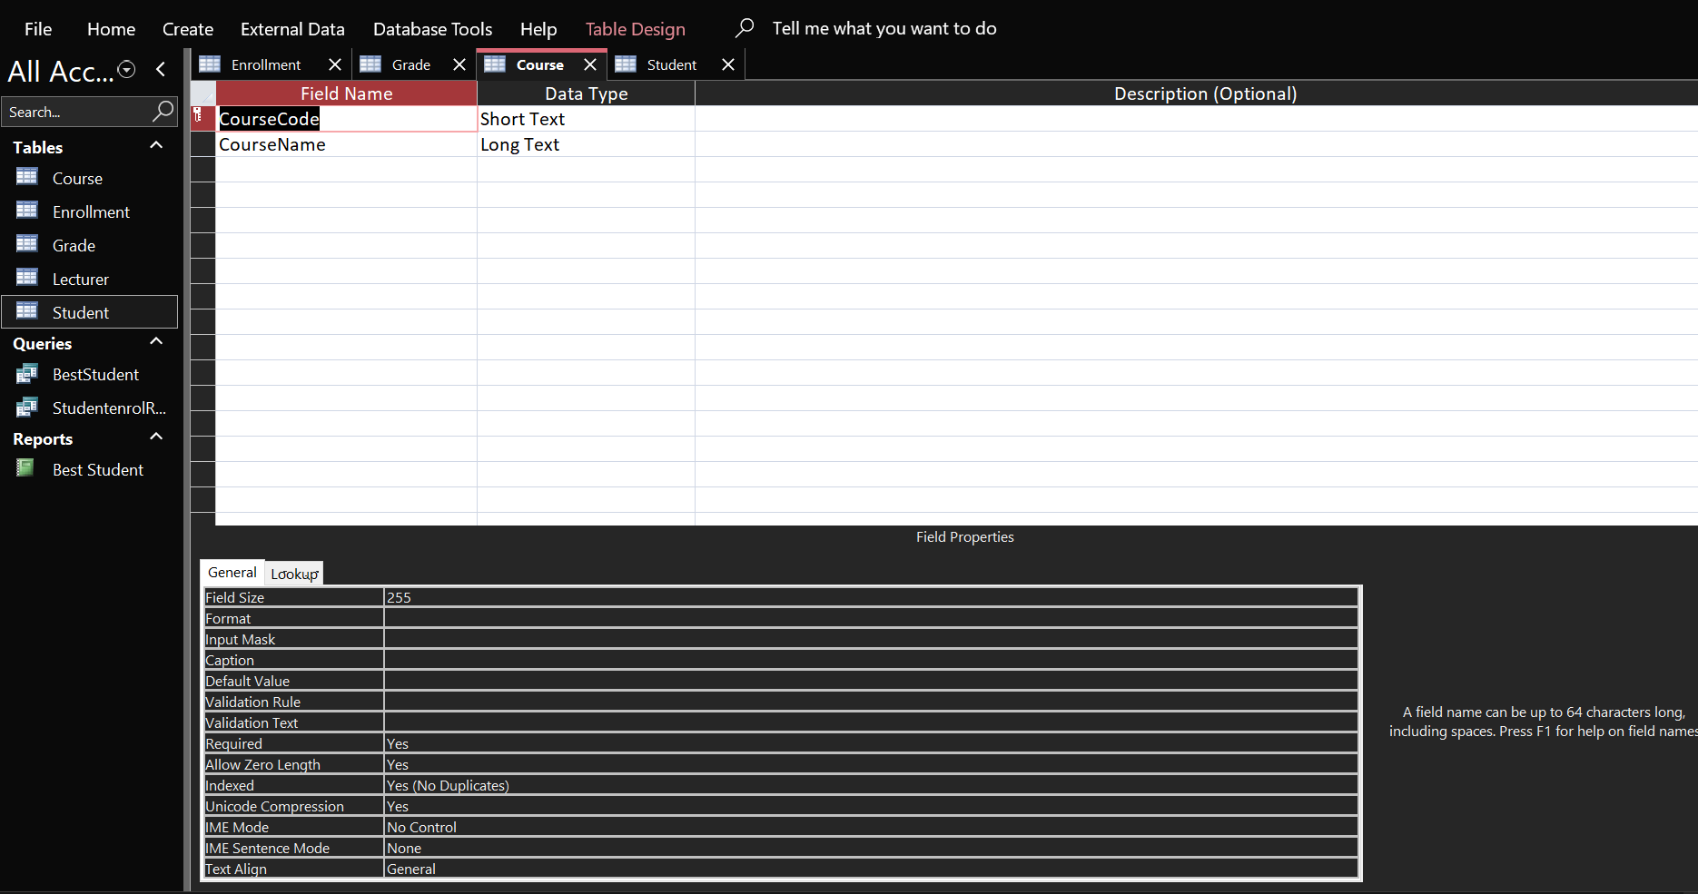Datasheet View

Design View

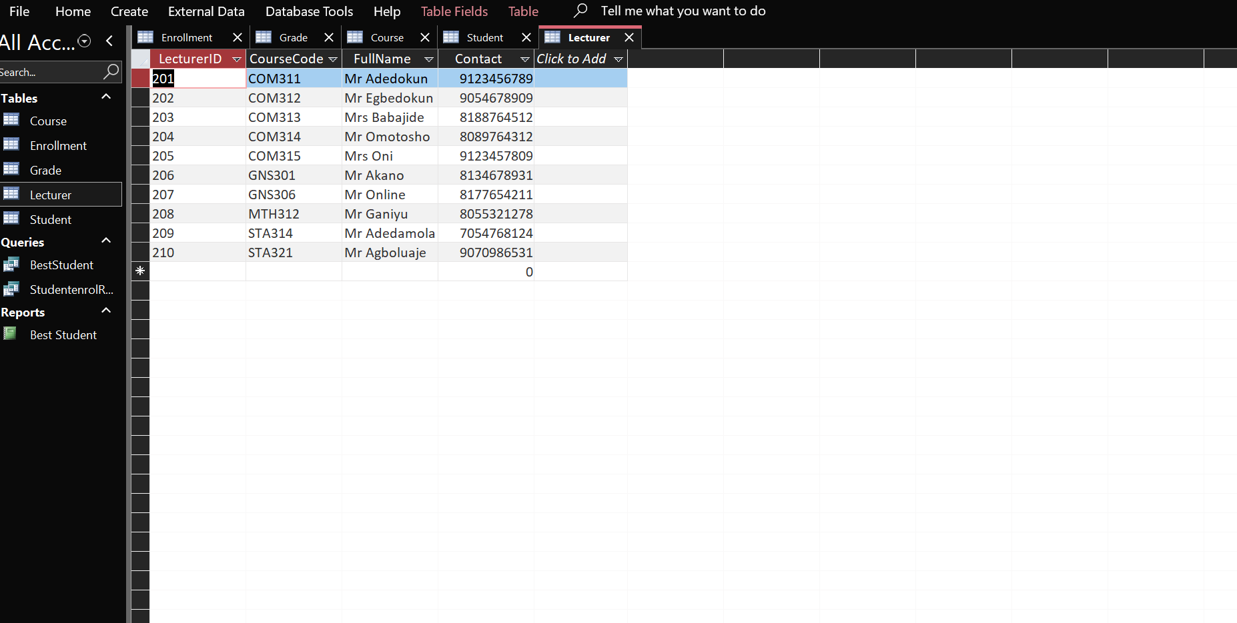**Course Table**

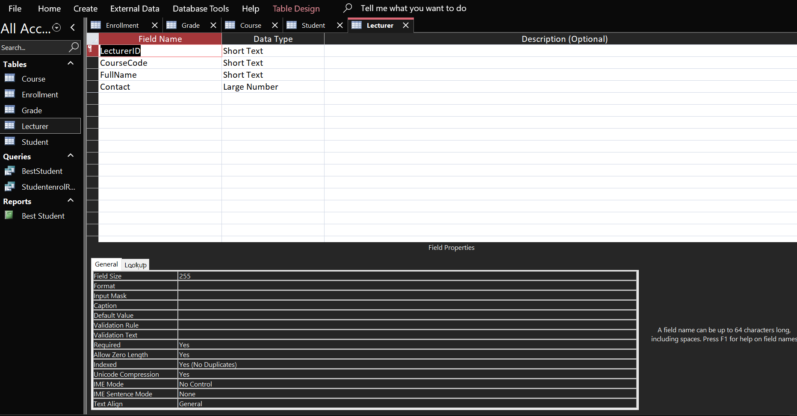Datasheet View

Design View

**QUERY FOR COURSE WITH THE LEAST NUMBER OF STUDENT ENROLLMENT**

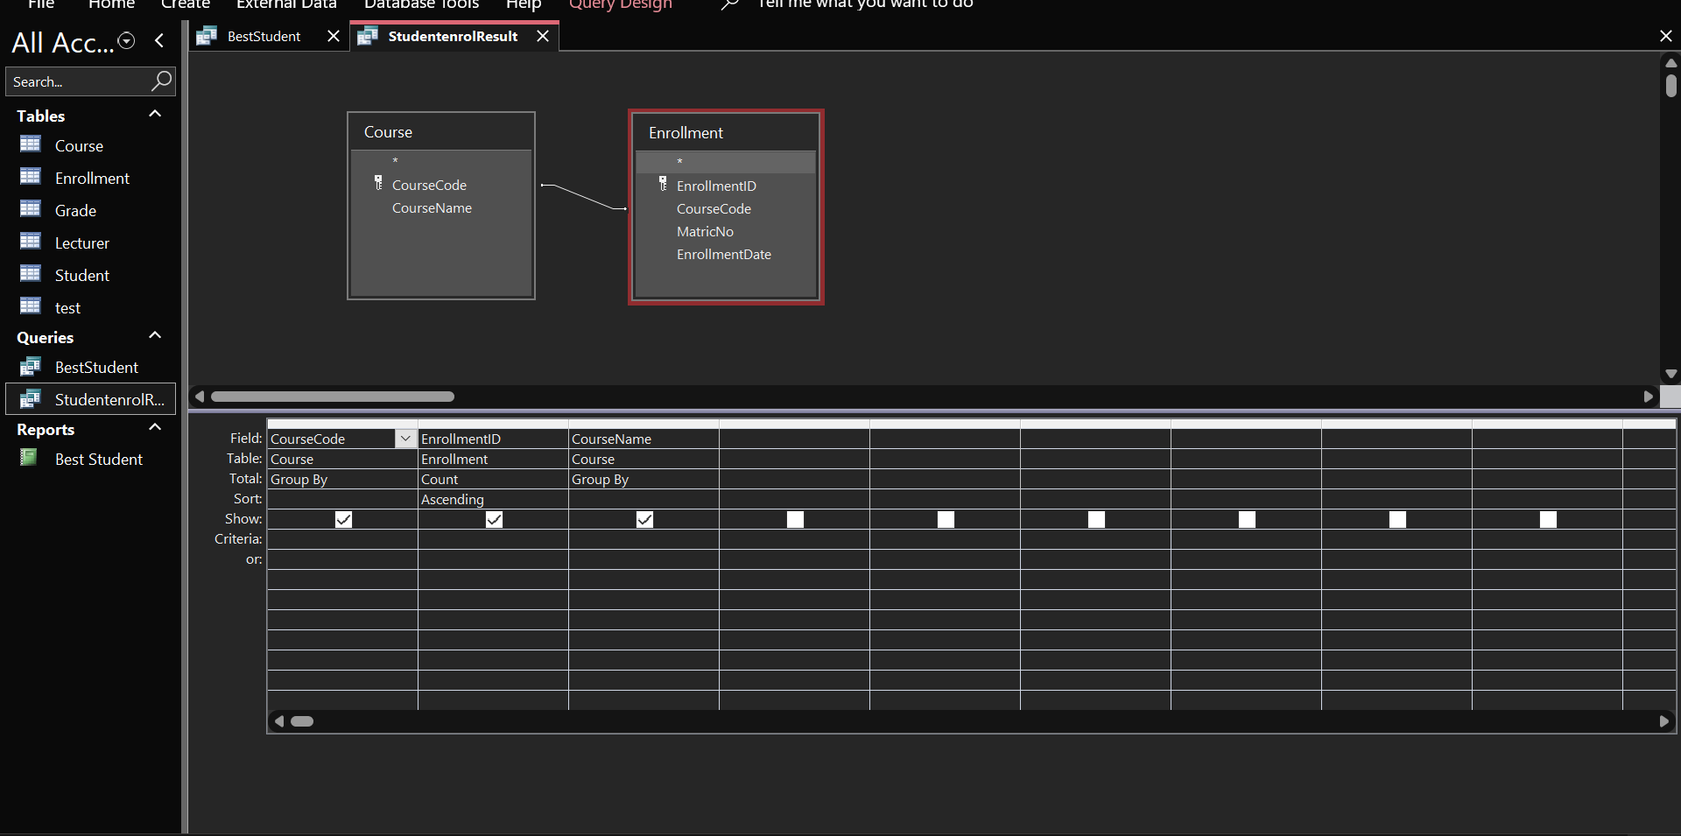**Design View**

**Datasheet View (Output)**

**QUERY FOR BEST STUDENT IN COM 312**

Design View

Datasheet View (Output)

